Name:_________________________
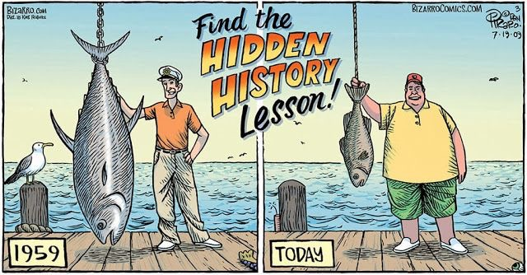
Adapted from “Quincy High school, 2073 Marine Science, [Class handout] Murray”
Around the world people rely on fish for protein, and fishing is the main source of income for millions around the world. Historically, we have seen the seas and oceans as vast and limitless. However, increasing demand as well as unsustainable fishing practices over the last 50 years are pushing fish stocks to the tipping point.

More than 85 percent of the world's fisheries have been pushed to or beyond their biological limits and are in need of strict management to restore them. Several important commercial fish populations (such as Chilean Sea Bass) have declined to the point where their survival as a species is threatened. Fishing of top predators, such as tuna and groupers, is changing marine communities, which lead to an abundance of smaller marine species, such as sardines and anchovies.

Fisheries for the most sought-after species, like orange roughy, Chilean sea bass, and bluefin tuna have collapsed. In 2003, a scientific report estimated that industrial fishing had reduced the number of large ocean fish to just 10 percent of their pre-industrial population.

Part 1 – The Problem: (Answers can be found at www.overfishing.org)
1. What is overfishing? (Pick one of the three definitions) ________________________________________________________________________________________________________________________________________________________________________________________________________________________________________________________________________________________________
2. What is causing overfishing? ________________________________________________________________________________________________________________________________________________
3. How large is our current global fishing capacity? ________________________________________________________________________________________________________________________________________________
4. Use the example of Newfoundland to explain why overfishing is a problem. Could this spread to other areas? ________________________________________________________________________________________________________________________________________________________________________________________________________________________________________________________________________________________________
5. What does fishing down the food web mean? ________________________________________________________________________________________________________________________________________________________________________________________________________________________________________________________________________________________________
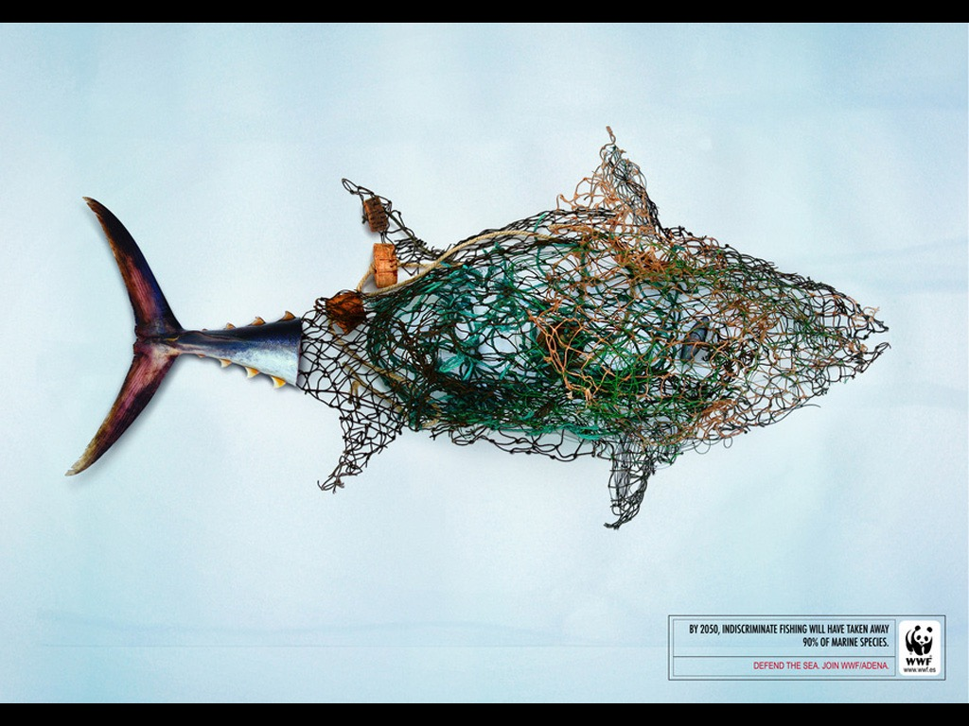

Part 2 - The Methods Answers can be found at
http://www.seafoodwatch.org/ocean-issues/fishing-and-farming-methods
Define the following types of fishing:
1. Trawls and Dredges ________________________________________________________________________________________________________________________________________________________________________________________________________________________
2. Purse Seine ________________________________________________________________________________________________________________________________________________________________________________________________________________________
3. Long Lining ________________________________________________________________________________________________________________________________________________________________________________________________________________________
4. Gillnetting ________________________________________________________________________________________________________________________________________________________________________________________________________________________
5. Harpooning ________________________________________________________________________________________________________________________________________________________________________________________________________________________
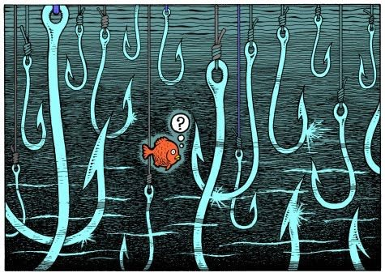
image source: https://s-media-cache-ak0.pinimg.com/564x/0e/20/32/0e2032f6cae12c8e21b8764afa2d8dac.jpg
Part 3 – The Reasons
Answers can be found at https://www.seafoodwatch.org/ocean-issues/wild-seafood
1.What is the current state of the World’s fisheries? ________________________________________________________________________________________________________________________________________________________________________________________________________________________
2. Why are large fish the first to be caught and how does this affect the World’s fisheries (think reproduction)? ________________________________________________________________________________________________________________________________________________________________________________________________________________________
3. What happens to large fish when fishermen start to focus on animals that are lower on the food chain? ________________________________________________________________________________________________________________________________________________________________________________________________________________________

Part 4 – Unintended Consequences Answers found on same site
1. How many fish are caught either dead or dying and are simply discarded? ________________________________________________________________________________________________________________________________________________________________________________________________________________________
2. Describe by-catch. ________________________________________________________________________________________________________________________________________________________________________________________________________________________
3. What are the two fishing methods with the most by-catch? ________________________________________________________________________________________________________________________________________________________________________________________________________________________
4. How many sharks and sea turtles have been affected by by-catch? ________________________________________________________________________________________________________________________________________________________________________________________________________________________
Part 5 – The Solution 1.
Read the article at
http://www.nmfs.noaa.gov/sfa/management/catch_shares/about/what_are_catch_shares.html
Explain how Catch Share Programs are helping to eliminate overfishing. ________________________________________________________________________________________________________________________________________________________________________________________________________________________ ________________________________________________________________________________________________________________________________________________________________________________________________________________________ ________________________________________________________________________________________________________________________________________________________________________________________________________________________ ________________________________________________________________________________________________________________________________________________________________________________________________________________________ ________________________________________________________________________________________________________________________________________________________________________________________________________________________ ________________________________________________________________________________________________________________________________________________________________________________________________________________________ ________________________________________________________________________________________________________________________________________________________________________________________________________________________ ________________________________________________________________________________________________________________________________________________________________________________________________________________________ ________________________________________________________________________________________________________________________________________________________________________________________________________________________ ________________________________________________________________________________________________________________________________________________________________________________________________________________________

2. What is aquaculture and how do you think it could be used to save the worlds fisheries?
Answer at https://www.seafoodwatch.org/ocean-issues/aquaculture/wild-fish
________________________________________________________________________________________________________________________________________________________________________________________________________________________ ________________________________________________________________________________________________________________________________________________________________________________________________________________________ ________________________________________________________________________________________________________________________________________________________________________________________________________________________ ________________________________________________________________________________________________________________________________________________________________________________________________________________________ ________________________________________________________________________________________________________________________________________________________________________________________________________________________ ________________________________________________________________________________________________________________________________________________________________________________________________________________________ ________________________________________________________________________________________________________________________________________________________________________________________________________________________ ________________________________________________________________________________________________________________________________________________________________________________________________________________________ ________________________________________________________________________________________________________________________________________________________________________________________________________________________ ________________________________________________________________________________________________________________________________________________________________________________________________________________________

Use the following website to fill in the blanks on the chart
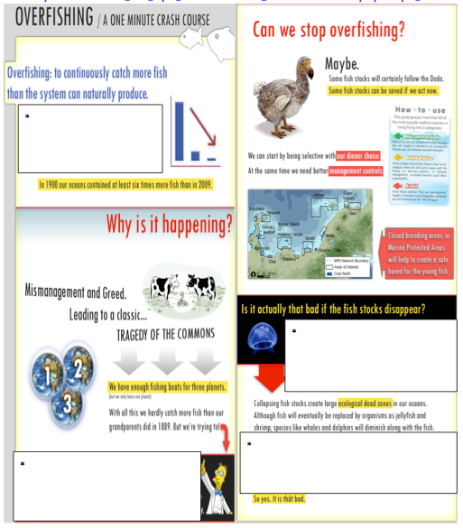
http://overfishing.org/pages/Overfishing_in_one_minute.php?w=pages

"Overfishing." WWF. World Wildlife Fund, n.d. Web. 05 Feb. 2017.
Society, National Geographic. "Overfishing -- Pristine Seas." National Geographic. N.p., n.d. Web. 05 Feb. 2017.

