Bubbling Cabomba pondweed
Investigation 1: counting gas bubbles at different light intensities

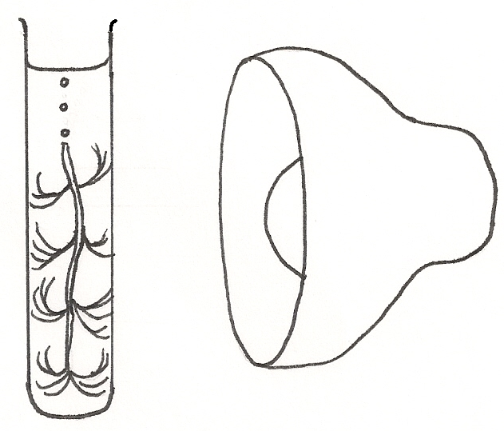Photosynthesis is a chemical reaction. You need to be able to identify and discuss the factors that affect the rate of photosynthesis.

The easiest rate-limiting factor to investigate using bubbling Cabomba is light intensity. Light intensity can be changed by moving a plant to different distances from a lamp.

Like many other water plants, Cabomba has specialised tissue called aerenchyma that allows oxygen to diffuse inside the plant. If you cut through the aerenchyma this gas can escape. We can count the bubbles in a set time to investigate the rate of photosynthesis under different conditions.

Safety: Take care with use of water near electrical equipment. Ensure hands are dry when using lamps.

Apparatus

- Approx 5-7cm long piece of Cabomba
- Boiling tube
- Lamp
- Meter ruler / measuring tape
- Stop clocks / timers
- 1% sodium hydrogen carbonate (or water)

Setting up your bubbling Cabomba

- Half fill a boiling tube with 1% sodium hydrogen carbonate (or water)
2. Place your Cabomba into the boiling tube (upside down – cut end up)
3. Gently push the Cabomba down – care not to snap the stem
- Top up the boiling tube and place in a rack
5. Position a lamp to shine onto the leaves of the plant
6. Bubbles of gas should be seen emerging from the cut end after 1-2 minutes. If bubbles do not appear, cut the end of the stem again to freshen it up

Investigation: How does light intensity affect the rate of photosynthesis?

- Fix a ruler to your desk so that you can easily move your plugged-in lamp along it.
- Place the boiling tube rack (and plant) at 0cm along the ruler
- Place the lamp as close as you can to 0cm so that it’s shining on the leaves
- Allow the plant to adjust to this light
- Count the number of bubbles escaping from the cut end in one minute
- Record your data (repeat if time allows)
- Repeat the experiment for all of the distances you decided, starting with the shortest distance and getting further away from the lamp

Set up a table with headings like the one below for your investigation

Lamp Distance from plant (cm) | Number of bubbles per minute
Lamp Distance from plant (cm) | Test 1 | Test 2 | Average
0

Bubbling Cabomba pondweed
Investigation 2: counting oxygen bubbles at different wavelengths of light

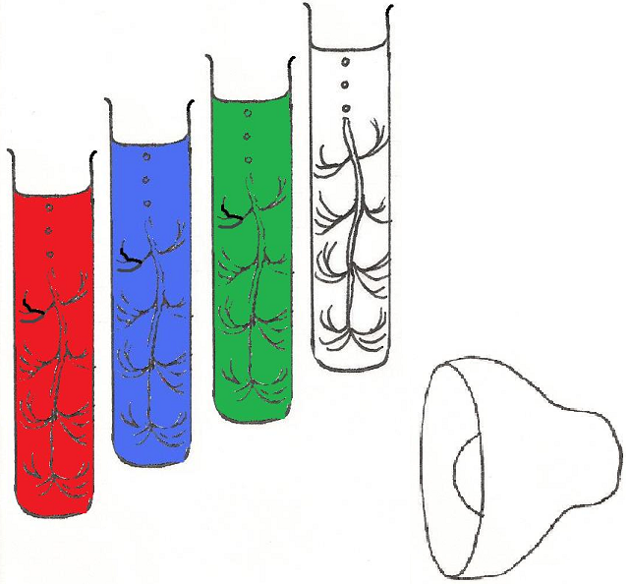
Photosynthesis is a chemical reaction. You need to be able to identify and discuss the factors that affect the rate of photosynthesis. One factor that can be investigated is the wavelength (colour) of light. We can do this by using filters that absorb most colours and let only one colour through.

As light is a mixture of the primary colours red, blue and green, these are
the most obvious filters to start investigating.

Like many other water plants, Cabomba has specialised tissue called aerenchyma that allows oxygen to diffuse inside the plant. If you cut through the aerenchyma this gas can escape. We can count the bubbles in a set time to investigate the rate of photosynthesis under different conditions.

Safety: Take care with use of water near electrical equipment. Ensure hands are dry when using lamps.

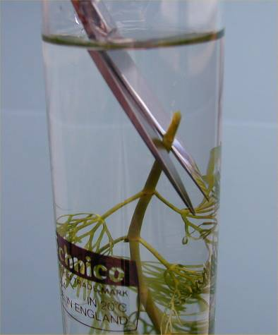
Apparatus

- Approx 7cm long piece of Cabomba
- Boiling tube
- Lamp
- Meter ruler / measuring tape
- Stop clocks / timers
- Acetate film in red / blue / green (maybe a clear one if using as a control)
- 1% sodium hydrogen carbonate (or water)
- sticky tape
Snipping the cut end under water to refresh the sample

Setting up your bubbling Cabomba

- Half fill a boiling tube with 1% sodium hydrogen carbonate (or water)
- Place your Cabomba into the boiling tube (upside down – cut end up)
- Gently push the Cabomba down – care not to snap the stem
- Top up the boiling tube and place in a rack
- Position a lamp to shine onto the leaves of the plant
- Bubbles of gas should be seen emerging from the cut end after 1-2 minutes
- If bubbles do not appear, cut the end of the stem again to freshen it up

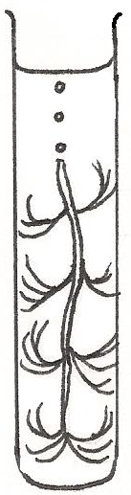Investigation: How does wavelength (colour) of light affect the rate of photosynthesis?

- Place the lamp at a chosen distance from your plant e.g. 10cm
- Allow the plant to adjust to this white light (or wrap a clear filter round first)
- Count the number of bubbles escaping from the cut end in one minute, record data, repeat if time
- Wrap ready cut to size red acetate all around your tube and sticky tape in place.
- Count the number of bubbles escaping from the cut end in one minute, record data, repeat if time
- Replace the red acetate with blue acetate, then with green acetate and repeat with each
- Always make sure the sticky tape faces away from the light

Set up a table with headings like the one below for your investigation:
Filter (acetate) colour | Colour of light getting into the boiling tube | Number of bubbles per minute
Filter (acetate) colour | Colour of light getting into the boiling tube | Test 1 | Test 2 | Average
Clear / none | All colours
Red
Blue
Green

Bubbling Cabomba pondweed
Investigation 3: measuring the volume of oxygen with a pipette
Photosynthesis is a chemical reaction. You need to be able to identify and discuss the factors that affect the rate of photosynthesis. The easiest rate limiting factor to investigate using bubbling Cabomba is light intensity. Light intensity can be varied by moving a plant different distances from a lamp. Measuring the volume of oxygen produced at each distance will show how light intensity affects the rate of photosynthesis.

Like many other water plants, Cabomba has specialised tissue called aerenchyma that allows oxygen to diffuse inside the plant. If you cut through the aerenchyma this gas can escape. We can find the volume of oxygen produced in a set time to find the rate of photosynthesis.

Safety: Take care with use of water near electrical equipment. Ensure hands are dry when using lamps.

Apparatus

- Approx 7cm long piece of Cabomba
- Boiling tube
- Lamp
- Meter ruler / measuring tape
- Stop clocks / timers
- 1% sodium hydrogen carbonate (or water)
- Pipettes
- Scissors

Setting up your bubbling Cabomba

- Half fill a boiling tube with 1% sodium hydrogen carbonate (or water)
- Place your Cabomba into the boiling tube (upside down – cut end up)
- Gently push the Cabomba down – care not to snap the stem
Snipping the cut end under water to refresh the sample
- Top up the boiling tube and place in a rack
- Position a lamp to shine onto the leaves of the plant
- Bubbles of gas should be seen emerging from the cut end after 1-2 minutes
- If bubbles do not appear, cut the end of the stem again to freshen it up

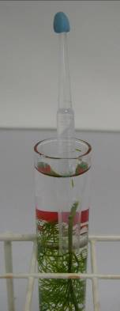
Investigation: How much oxygen is produced by a plant in a set time?

You will need to set up a pipette filled with 1% sodium hydrogen carbonate (or water) over the cut end of your Cabomba.

To do this:

- Fill a plastic pipette with 1% sodium hydrogen carbonate solution (or water).
- With the tip pointing up, dry the tip with a paper towel and seal it up using blu-tack.
- With the tip pointing down, cut off the bulb of the pipette, catching the spilled liquid in a small beaker/weighing boat.
- Top up the snipped pipette using the spilled liquid
- Without spilling any liquid, turn the pipette upside down over your cut Cabomba stem
- Place the lamp at your chosen distance so that it shines on the Cabomba leaves
- Leave it for the length of time your teacher suggests
- After this time has elapsed, use the markings on the pipette to work out the volume of oxygen produced by your plant in that time.
Tip of pipette sealed with Blu-tack. The pipette bulb has been cut off and the cut end placed over the cut Cabomba stem

Bubbling Cabomba pondweed
Investigation 4: measuring the volume of gas with a microsyringe
Photosynthesis is a chemical reaction. You need to be able to identify and discuss the factors that affect the rate of photosynthesis. The easiest rate limiting factor to investigate using bubbling Cabomba is light intensity. Light intensity can be varied by moving a plant different distances from a lamp. Measuring the volume of oxygen produced at each distance will show how light intensity affects the rate of photosynthesis.

Like many other water plants, Cabomba has specialised tissue called aerenchyma that allows oxygen to diffuse inside the plant. If you cut through the aerenchyma this gas can escape. We can find the volume of oxygen produced in a set time to find the rate of photosynthesis.

Safety: Take care with use of water near electrical equipment. Ensure hands are dry when using lamps.

Apparatus

- Approx 7cm long piece of Cabomba
- Boiling tube
- Lamp
- Meter ruler / measuring tape
- Stop clocks / timers
- 1% sodium hydrogen carbonate (or water)
- Microsyringes
- Clothes peg

Setting up your bubbling Cabomba
Snipping the cut end under water to refresh the sample
- Half fill a boiling tube with 1% sodium hydrogen carbonate (or water)
- Place your Cabomba into the boiling tube (upside down – cut end up)
- Gently push the Cabomba down – care not to snap the stem
- Top up the boiling tube and place in a rack
- 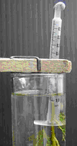Position a lamp to shine onto the leaves of the plant
- Bubbles of gas should be seen emerging from the cut end after 1-2 minutes
- If bubbles do not appear, cut the end of the stem again to freshen it up

Investigation: How much oxygen is produced by a plant in a set time?

You will need to set up a microsyringe filled with 1% sodium hydrogen carbonate (or water) over the cut end of your Cabomba.

To do this:

- Seal off the end of a dry microsyringe with blu-tack.
- Use another microsyringe fitted with a tip to fill the first microsyringe with 1% sodium hydrogen carbonate solution (or water).
- Inverted this over your cut Cabomba stem and fix with a peg
Filled microsyringe sealed with blu-tack and placed over the cut Cabomba stem to collect oxygen.
- Place the lamp at your chosen distance so that it shines on the Cabomba leaves
- Leave it for the length of time your teacher suggests
- After this time has elapsed, use the markings on the microsyringe to work out the volume of oxygen produced by your plant in that time.

